Classification Report:
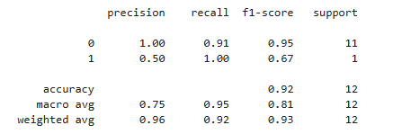
Confusion Matrix:
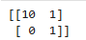
- What is the percentage of correct classification all the classes (Purchased / Not purchased) to the total input of test set?
Accuracy 92%

- What is the percentage of correct classification of “Not purchased” to the total “Not purchased “ class in the test set?
Recall of the class ‘Not purchased’ is 91%

- What is the percentage of correct classification of “Purchased” to the total “Purchased “ class in the test set?
Recall of the class ‘Purchased’ is 100 %

- What is the percentage of correctly classified as “Not purchased” to the sum of correctly and incorrectly classified as “Not Purchased” in the test set?
Precision of the class ‘Not purchased’ is 100%

- What is the percentage of correctly classified as “Purchased” to the sum of correctly and incorrectly classified as “Purchased” in the test set?
Precision of the class ‘Purchased’ is 50%

- What is the overall performance of “Not purchased”?
F1 Measure for “Not purchased” is 95%

- What is the overall performance of “Purchased”?
F1 Measure for “Purchased” is 67%

- What is the average performance?
Macro Average for Precision, Recall & F1 Measure are 75%, 95% & 81% respectively.
- What is the sum of product of proportion rate?
The Weighted average for Precision, Recall & F1 Measure are 96%, 92% and 93% respectively.

